**ShopBridge Application**

Steps to Run Application

1] Download Shop Bridge application Code form **github**

Link: <https://github.com/BPrafulla/ThinkBridgeSolution.git>

* First Create a db with required Schema by Script provided in code.

2] Open [**ThinkBridgeSolution.sln**](https://github.com/BPrafulla/ThinkBridgeSolution/blob/master/ThinkBridgeSolution.sln)in Visual Studio 2017/19

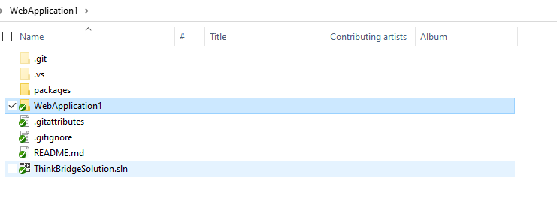

3] After open application, open **ItemController.cs** filepress F5 to run.

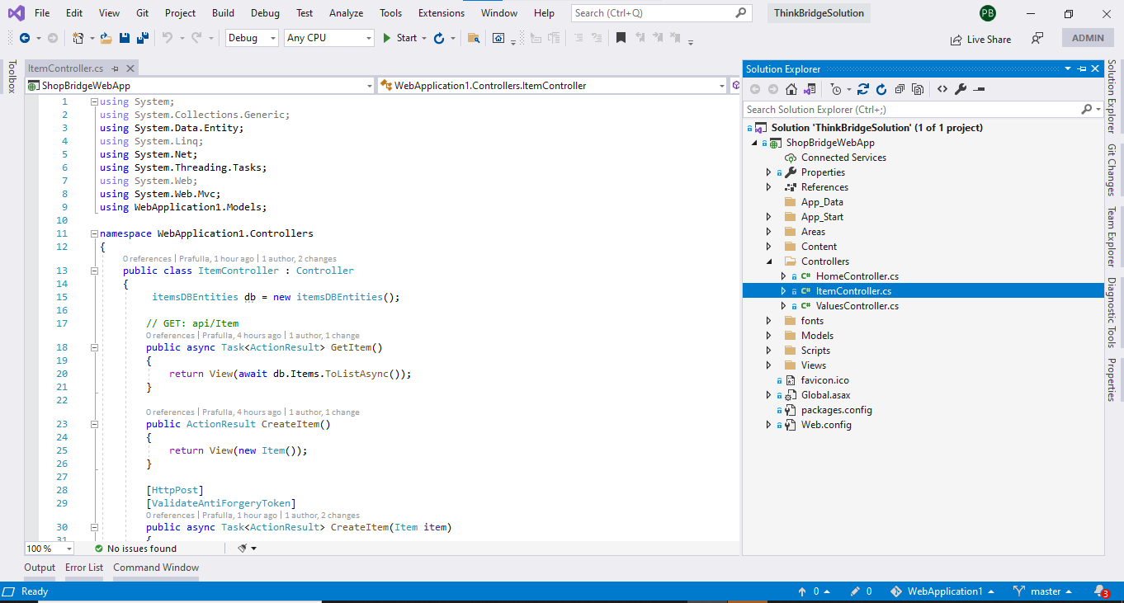

4]App will load on browser

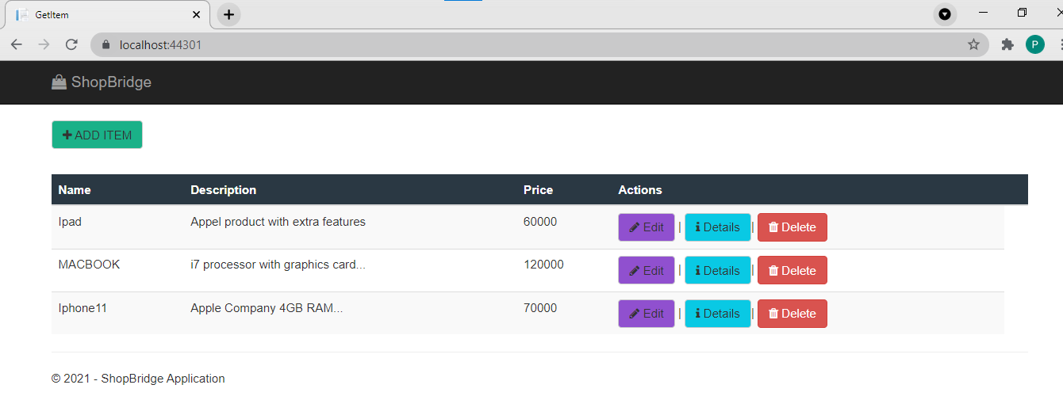

5]You can do Add, Edit, View or Details, Delete Items from Db .

6]**ADD** Operation screen

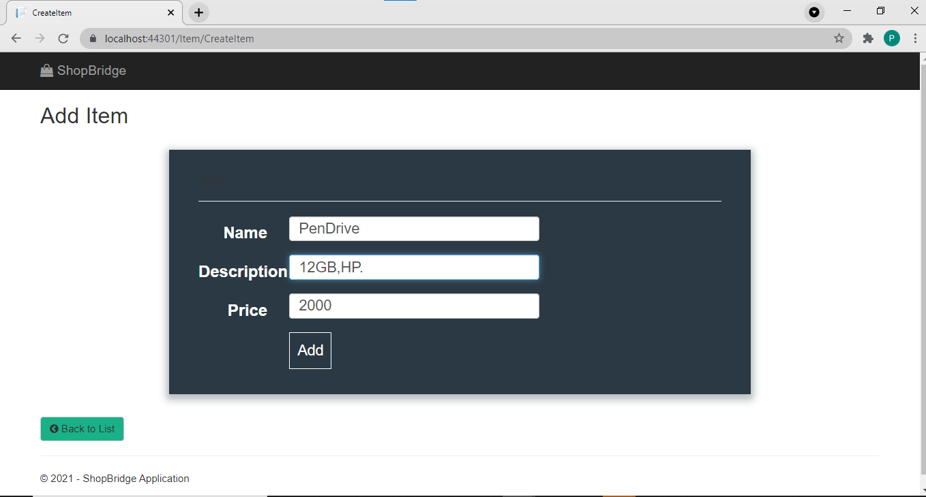

* Successfully **Added** with Success Message.

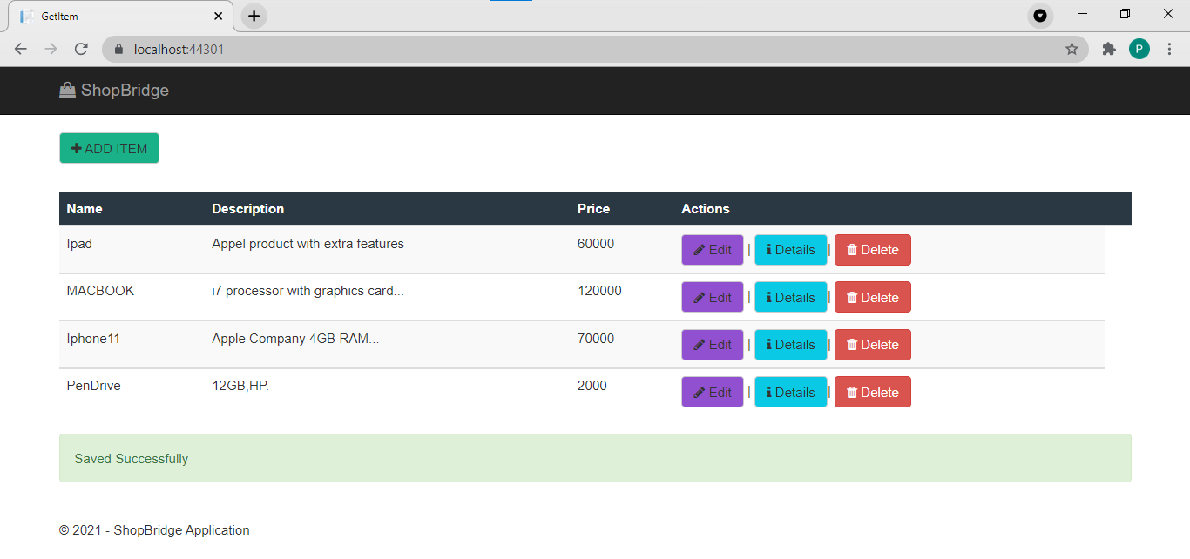

7]**Edit** Operation: **Changing Description and Price**

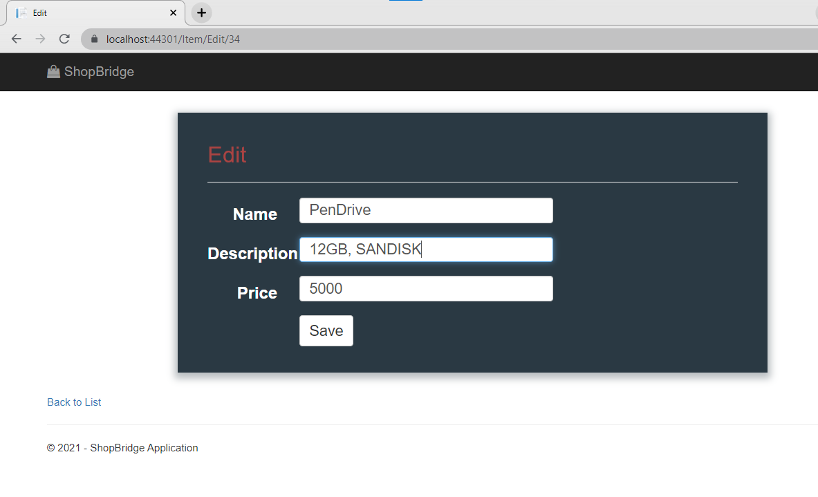

* Successfully updated with Success Message.

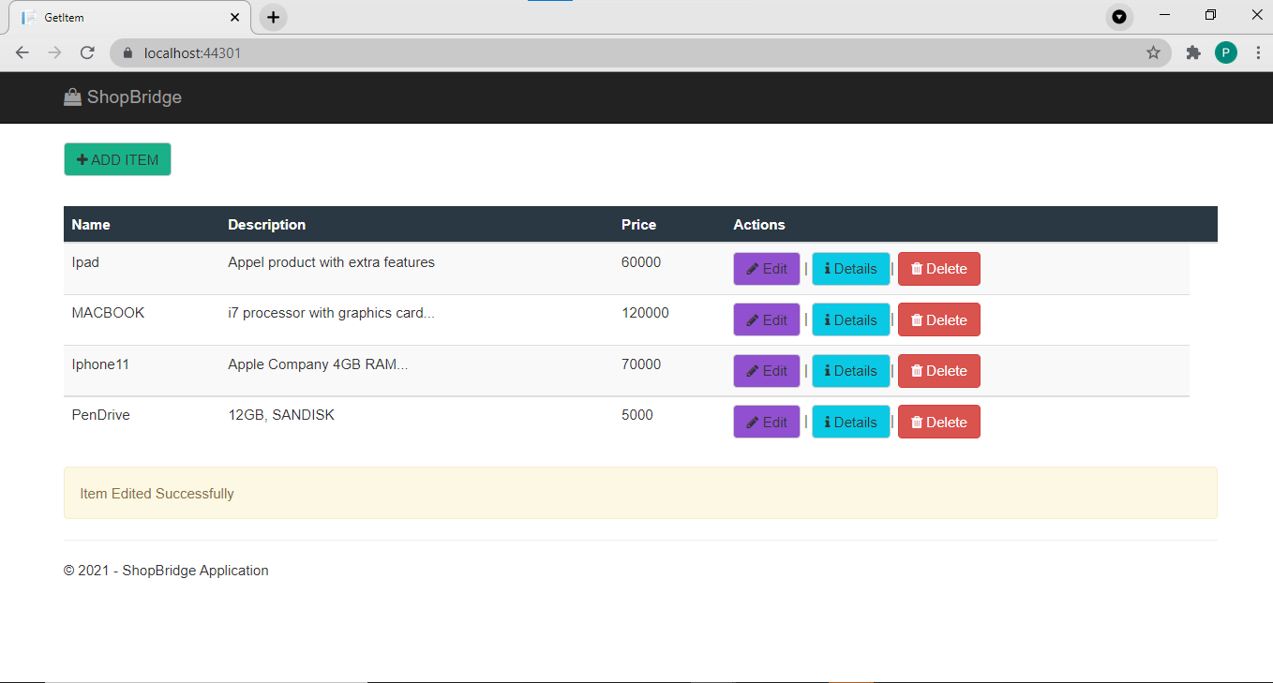

8] **View**/ **Details** Operation:

--Clicked on **Macbook** Item’s **Detail** button

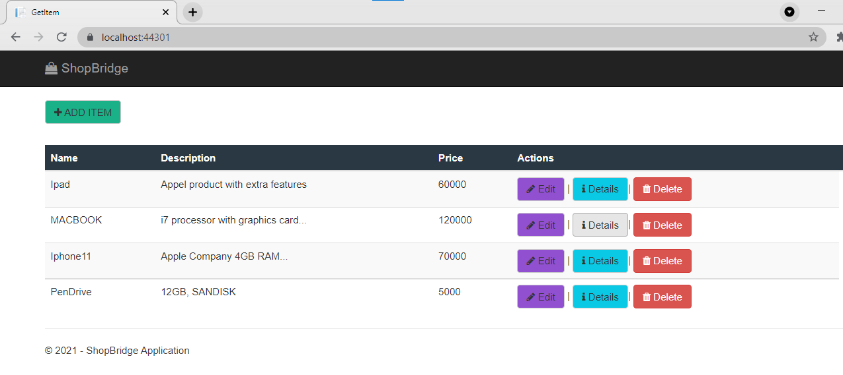

* Shows all details for that Item.

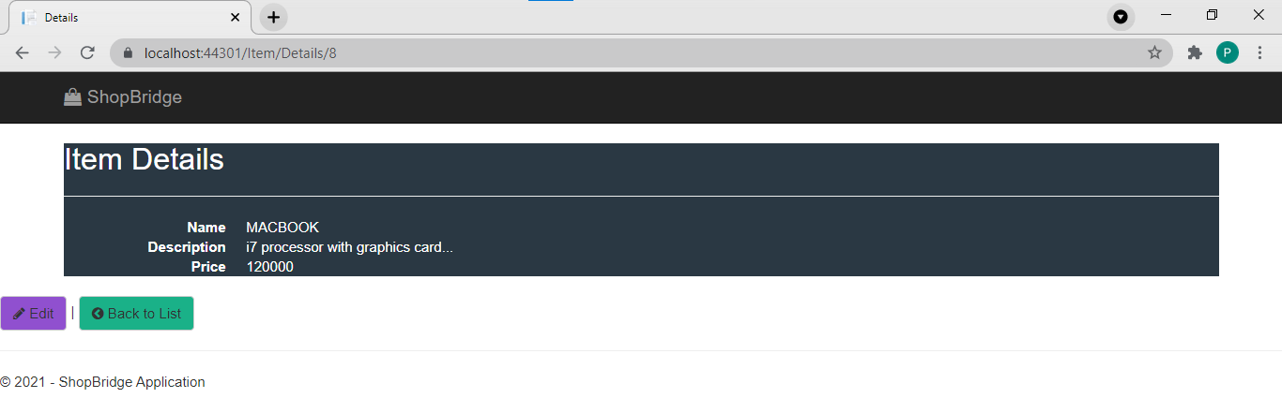

9]**Delete** Operation:

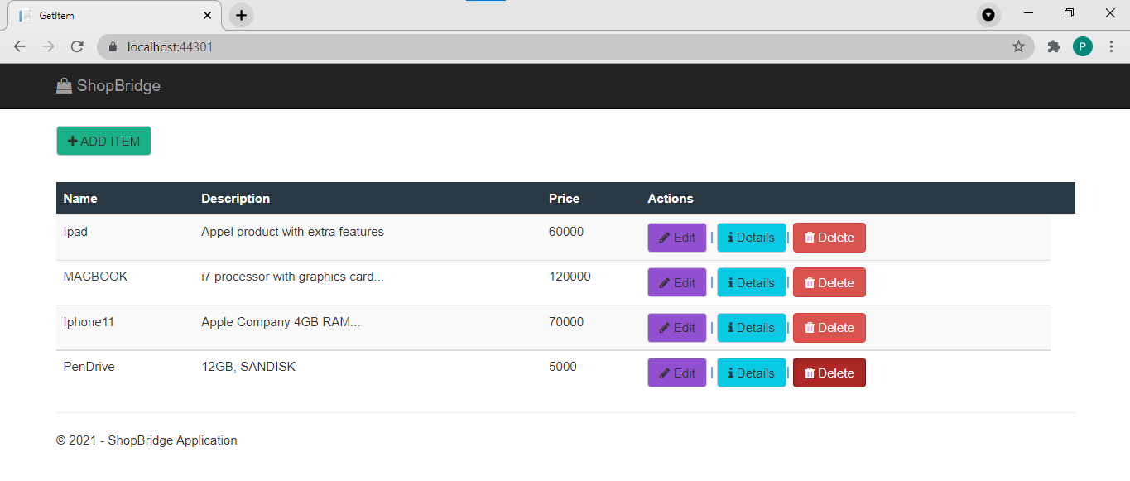

* Eg. **Deleting** PenDrive Item
* Open a new page for delete to ask confirmation for Item

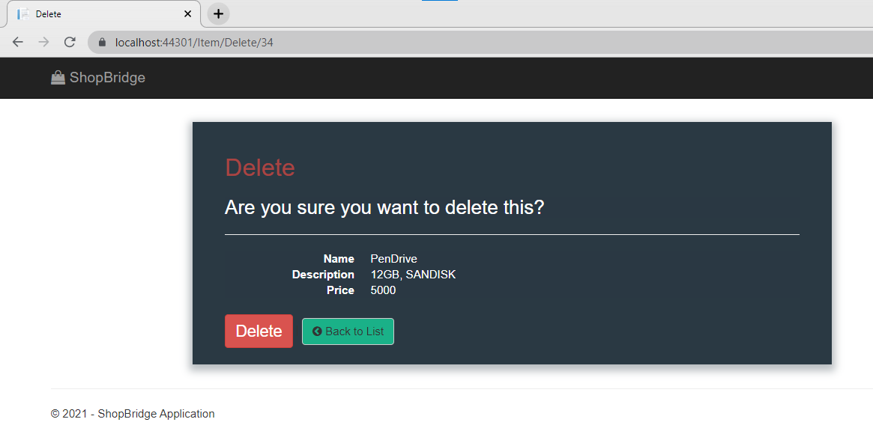

* Clicked on Delete it will delete that Item and return to Item List page and shows success message.

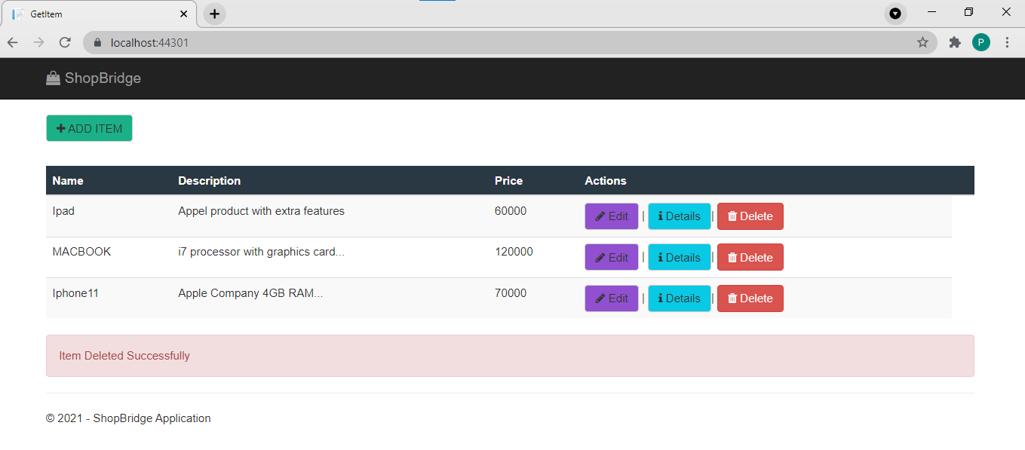

10] Validations :



